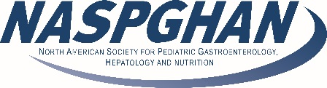
Mentor/Mentee Program 2022
Sponsored by the NASPGHAN Research Committee
APPLICATION FORM

MENTEE NAME: _______________________________________________________
MENTEE INSTITUTION: _________________________________________________
MONTH/YEAR OF EXPECTED GRADUATION: _______________________________
(This program is for Graduation Classes of either 2023 or 2024)
PROGRAM DIRECTOR NAME:____________________________________________
PROGRAM DIRECTOR SIGNATURE: ______________________________________
LOCAL RESEARCH MENTOR:____________________________________________
AREA OF RESEARCH: ______________________________________________________________________
______________________________________________________________________

Please complete the questions below and submit your completed application to rbailey@naspghan.org by August 15, 2022.

- What are your career goals?

- What qualities or personality style do you work best with?

- What are you looking for in a mentor?

