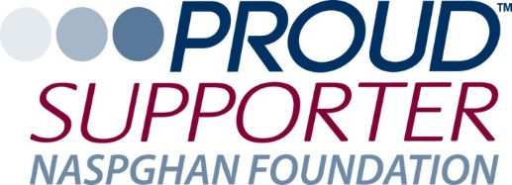

The NASPGHAN Foundation would like to thank you for your continued support, especially over the last tumultuous years. We hope we can also depend on your support of this year’s Partners Program. Your participation is more important than ever as we adjust to the current situation and seek new ways to communicate and collaborate with our corporate Partners. It is critical that we continue our efforts to grow our field and provide education to our members and families we serve. This is not possible without you.

Our new program year will launch on September 1, 2023. We invite your company to work strategically with us to advance pediatric patient care through research, education, policy, advocacy, and emerging issues by renewing your membership as a Partner. We will continue the tradition of the annual Partners Program to provide you with updates on NASPGHAN, the Foundation, our advocacy efforts and more generally, the “state of pediatric gastroenterology.” We will also work with you to schedule a one-on-one meeting with your team and NASPGHAN/Foundation leadership during the annual meeting.

Below are the 2023-2024 benefit level details for your consideration as well as an application form. Please let me know if you would like to set up a call to discuss the benefits and your company’s partnership with the NASPGHAN Foundation or details regarding the annual meeting.

Ongoing open communication around the science and practice of pediatric gastroenterology, hepatology and nutrition can only make the field stronger for all of us. Over the years, we have seen how shared insights and information can identify common issues and challenges. During these challenging times, it will be even more important to work together and build on the ideas which have emerged from our prior collaborations.

We are accepting applications now with the final application deadline July 1, 2023, so that we have time to schedule meetings and add all of the proper recognition on our website and program materials/signs.

Thank you, in advance, for your consideration and generous support.

Sincerely,
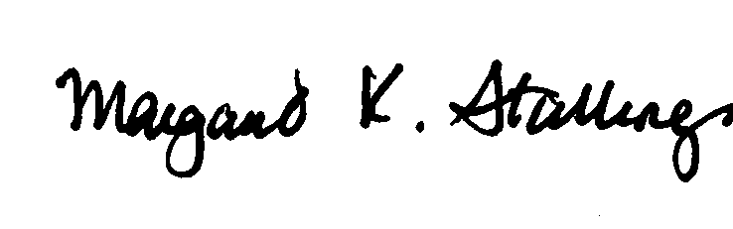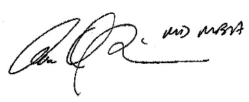
Margaret Stallings Ann Scheimann MD, MBA
Executive Director President
NASPGHAN Foundation NASPGHAN Foundation

NASPGHAN Foundation Digestive Health for Life Partners Program September 1, 2023 – August 30, 2024

The NASPGHAN Foundation Digestive Health for Life Partners Program offers opportunities for your company to engage with NASPGHAN and NASPGHAN Foundation leadership who represent the pediatric gastroenterology, hepatology and nutrition community. Take advantage of the following partnership benefits as a, Silver, Gold or Platinum member:

PREMIER STATUS MEMBERSHIP LEVELS

$5,000 Silver Partner
- Tiered logo recognition on the NASPGHAN Foundation home page with link to corporate home page
- NASPGHAN Foundation partners ribbons at NASPGHAN Annual Meeting – designation on profile on meeting website
- Recognition in Foundation Annual Report
- One (1) face-to-face (or virtual) meeting with NASPGHAN leadership during Digestive Disease Week or the NASPGHAN Annual Meeting to discuss strategic direction and collaborative projects
- Customized plaque for your Annual Meeting exhibit booth
- Credits in opening slides at NASPGHAN Plenary Session during Annual Meeting
- Credits in slides during NASPGHAN Foundation Research Awards Ceremony
- Invitation to attend Partners Meeting during Annual Meeting 2023
- Recognition advertisement including logo in Journal of Pediatric Gastroenterology and Nutrition and JPGN Reports (the official journals of NASPGHAN and European Society for Pediatric Gastroenterology Hepatology and Nutrition - ESPGHAN) – sponsor logo in thank you ad
- Logo inclusion on Donor Wall of Honor at NASPGHAN Annual Meeting
- Right to use “Proud Supporter” logo (Provided by the NASPGHAN Foundation to be used for print/web/online sponsor educational materials or advertising)

$10,000 Gold Partner
All of the Silver Partner benefits plus the following:
- Two (2) face-to-face (or virtual) meetings with NASPGHAN leadership during Digestive Disease Week and the NASPGHAN Annual Meeting to discuss strategic direction and collaborative projects
- One (1) complimentary registration to the 2023 NASPGHAN Annual Meeting
- One (1) conference call annually with NASPGHAN topic expert
- Complimentary subscription to the Journal of Pediatric Gastroenterology and Nutrition and JPGN Reports
- Invitation to Foundation Donor Networking Reception
- Recognition on Annual Meeting app with link to company website

$20,000 Platinum Partner
All of the Gold Partner benefits plus the following:
- Two (2) complimentary registrations to NASPGHAN 2023 Annual Meeting
- VIP Pre-selection of premium booth space at the NASPGHAN Annual Conference in 2024
- Complimentary web banner ad* indicating your Platinum level of support for the Foundation on NASPGHAN Foundation home page from November 1, 2023 – September 30, 2024
- One (1) opportunity to submit company announcement in the Partners News Section of the NASPGHAN bi-annual newsletter*
- Inclusion of company logo and link to company website on GIKids.org
- Inclusion of company logo in NASPGHAN monthly newsletters
- Social Media mentions throughout the year highlighting your company as a proud supporter of the NASPGHAN Foundation
- Complimentary Annual Meeting registration list for pre-show mailings (emails not included)
- Complimentary Annual Meeting bag insert
- Complimentary tickets (2) to this year’s Social Event – Gala Anniversary Celebration

*Pending content review, scheduling and approval of usage by NASPGHAN Foundation

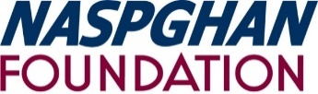
The NASPGHAN Foundation for Children’s Digestive Health and Nutrition
Digestive Health for Life Partners Program

Partners Program Application

September 1, 2023 – August 30, 2024
2023-2024 Membership Year

Member Categories:

Silver: $5,000 ________ Gold: $10,000 ________ Platinum: $20,000 _______

Company: __________________________________________________________
Contact Person
Title
Address: ____________________________________________________________

City State Zip
Phone
Email
Authorized Representative
Title

Signature
Date

Please respond no later than July 1, 2023
Make checks payable to: NASPGHAN Foundation
Send completed application and payment to:
714 N. Bethlehem Pike #300
Ambler, PA 19002
Attn: Partners Program
For more information please contact:
Debra Burrowes dburrowes@naspghan.org

